**QMST 5336 – Analytics**

**Texas State University**

**Term Project**

**05/10/2021**

**Guided by Dr. Emily Zhu**

**GROUP 4:**

**Anjali Goel**

**Harshal Y Shelare**

**Akshitha Karthick Kumar**

**ViswaShanti**

**Table of Contents**

**Introduction & Background** 2

**Data Collection** 2

**Data Visualization & Prediction** 3

**Analysis** 5

**Interpretation of Analysis Results** 9

**Conclusion** 9

**Shortcomings and/or Suggestions** 9

# **Introduction & Background**

We choose the topic of **Electric Vehicles** because it is a relevant topic in the world today.

Based on the statistics, USA car usage is 286 million motor vehicles. We need car to fulfill our daily errands and staying in USA without car is a nightmare.

Gas vehicles are only option in initial days, but people got electric vehicles as another option to think since 1985.

Electric vehicles evolving daily and coming with new features and multiple options. Companies encouraging their employees to take electric vehicles to promote green energy and providing subsidiaries. Ultimately customers are confused to choose between traditional/gas vehicles and electric vehicles.

Both Gas and electric vehicles have their own advantage and disadvantages. In the current project, we would like to go through the historic data and predict the car usage and prescribe the car (electrical or gas) considering multiple options.

# **Data Collection**

**Source**

The main aspect of research is the collection of data which plays a significant role in evaluating the search towards the research. The data was collected from government websites - the US Bureau of Statistics, and the US Energy Information Administration. The sources are listed below:

The data for electricity cost:

<https://www.eia.gov/electricity/data/browser/#/topic/7?agg=10&geo=g000000002&endsec=8&freq=M&start=200101&end=202102&ctype=linechart&ltype=pin&rtype=s&pin=&rse=0&maptype=0>

The data for gasoline costs:

<https://www.bls.gov/regions/midwest/data/averageenergyprices_selectedareas_table.htm>

**Data Cleaning and Selection**

These are the primary sources of the collected data. We have selected the data for the city of Austin, Texas. Since the electricity costs were available for the whole state of Texas, so we assumed the cost would be similar for the city of Austin as well.

The sample of data collected is in the monthly electricity and gasoline costs from January 2001 to January 2021. The data for both the costs are represented by two columns – Date and Cost. So, there are 2 columns and 241 rows in each of the datasets excluding the headers. The datasets were sorted by time columns in ascending order. The electricity costs are for the residential sector and the units are in the cost of electricity in kWh and the gasoline costs are per gallon. For the processing and analysis processes, the data is saved in CSV files. After the data is cleaned, it is used for analyzing trends and making predictions.

The data processing involved cleaning and removing any null values. No null values were found in both the sample datasets. Since the data is coming from the government websites, we have considered it to be accurate for the analysis. The monthly costs were taken into consideration because we are the electricity bills are generated monthly and for equal comparison, we have considered the monthly costs of gasoline as well. The sample data was considered sufficient as we have monthly data over the period of 21 years. So, we have based our prediction for these years.

# **Data Visualization & Prediction**

**Electricity Price Trend**

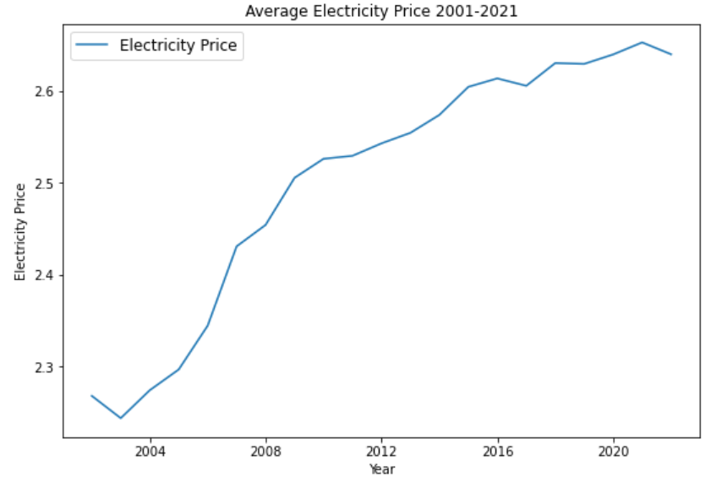

Figure1: Electricity Price Trend

This is historical price trend for electricity price. The graph shows that the electricity price was low in early 2000s and has been increasing constantly till at least January 2021. The minimum price of electricity was in January 2001 which was $7.73/kWh, and the highest was $13.7/kWh in October 2020.

**Gasoline Price Trend**

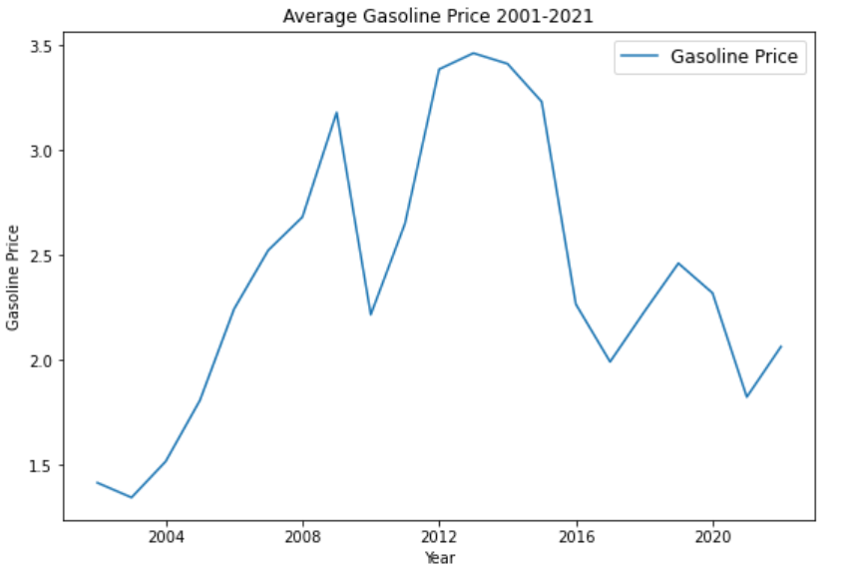

Figure2: Gasoline Price Trend

This is the historical price trend for gasoline price. The graph shows that the gasoline price was low in early 2000s and has spiked around 2008 and gone down around 2010 then back up. Overall, it is going up and down throughout the years. The sales and demand for gasoline directly correlate with the availability of coal and natural resources.

**Predictive Prices for electricity**

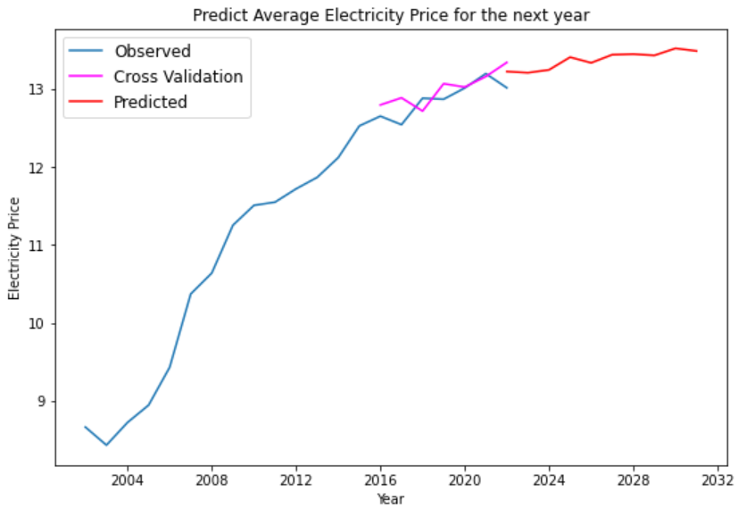

Figure3: Predictive Price for Electricity

The graph above shows the predictive prices for electricity. The price for electricity for next 10 years is minimally increasing. The average price for the years from 2021 to 2028 is $13.33/kWh.

**Predictive Prices for Gasoline**

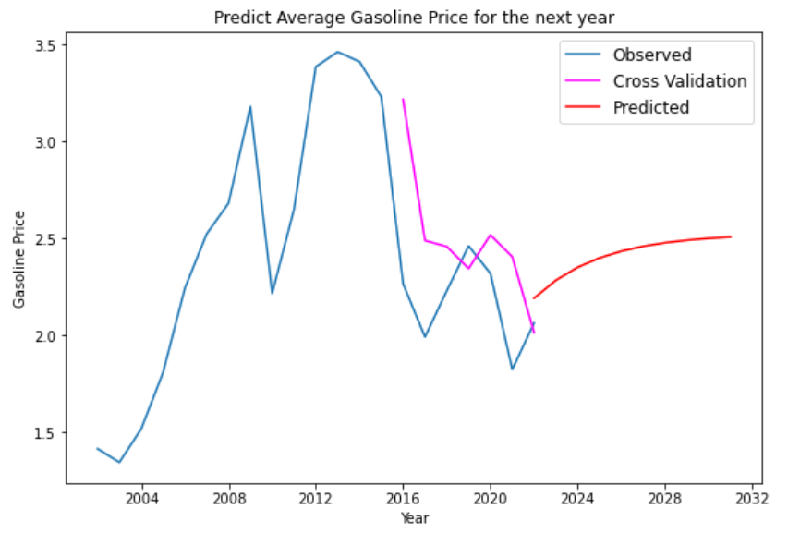

Figure4: Gasoline Price for Electricity

The graph above shows the prediction for gasoline prices. The gasoline price seems to increase gradually for the next 10 years compared to the historic data from 2016 to 2021. The average price of gasoline for a year from 2021 to 2028 is $2.45/gallon.

# **Analysis**

**Descriptive Analysis:** Based on the historical data, we have done data collection, data cleaning and visualization of past data. Electricity prices have increased minimally compared to gasoline prices which have increased substantially in last 21 years.

**Predictive Analysis:** Based on time-series predictions for the next 10 years, Gasoline Price is predicted to increase.

**Prescriptive Analysis:** Decision Tree Analysis

* **Decision Problem** Are Electric Vehicles more efficient to use than Regular vehicles in the next 5 years?
* **Decision Tree Comparison** Buying an EV Tesla Model 3 vs. Regular car BMW Series 3
* **Uncertainties**

**WFH policies**: Data based on 10 corporate companies

**Green energy subsidies:** $2500 for solar energy customers

**To solve a sequential decision problem, we have followed below methodology:**

* Identify all decisions and consequences (i.e. draw the decision tree).
* Evaluate the monetary payoffs at all terminal branches.
* Associate probabilities with all branches after event nodes.
* Perform BACKWARD INDUCTION (“Average out and fold back” the tree).

**In the below decision tree,** we have used square boxes which are decision nodes, circles which are event nodes and inverted triangles which are terminal nodes. Here in the above figure, we have uncertainties in the form of work from home policy as wfh=0% meaning a person will travel every day to office at 25 miles per day, wfh=50% meaning a person will travel alternatively to office and wfh=100% meaning a person does not have to travel to office but only to grocery and local travelling. Then next uncertainty is subsidy, which is state subsidy, if a person qualifies then $2500 will be deducted else no subsidy is provided. Also, cost of electricity is added to wfh uncertainty. Then we have considered travelling cost per mile as $0.4

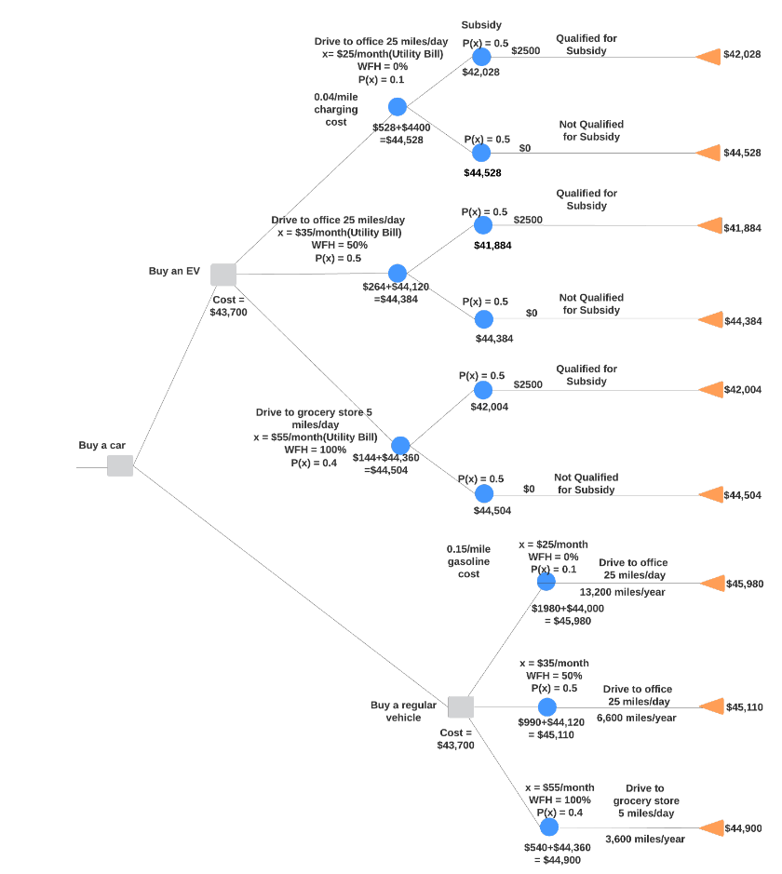

Figure5: Decision Tree for Electric Vehicle vs. Regular Vehicle

**In backward induction,** we have back traced the tree till root node to find the minimum amount by multiplying the payoffs value with probability at each event node. In this approach at every level minimum value is passed to next level backwardly till root node of tree. In this way we find which car is more beneficial in future to buy whether an Electric car or Regular car. And in this analysis, we have selected Tesla model 3 and BMW series 3.

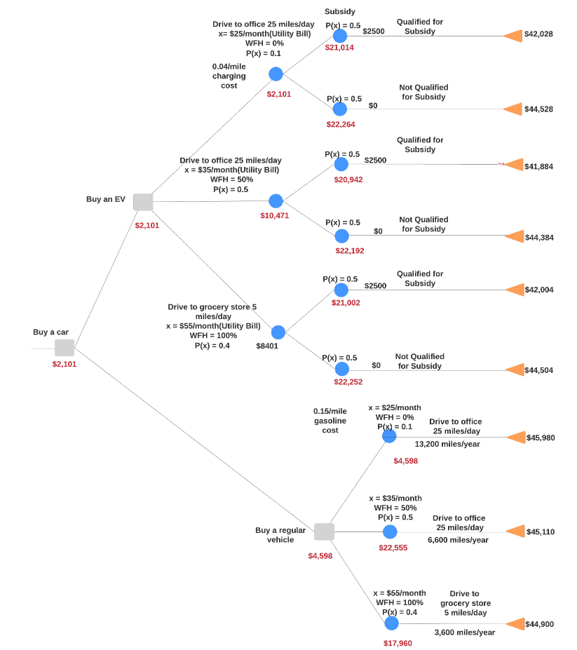

Figure6: Backward Induction for Electric Vehicle vs. Regular Vehicle

**In Optimal Strategy,** we have marked the path which is best suited in decision tree by backward induction. Therefore, if a person will buy an Electric car of Tesla model 3, he will be benefitted most if he will go to his/her office every day and probably able to secure State subsidy of $2500.

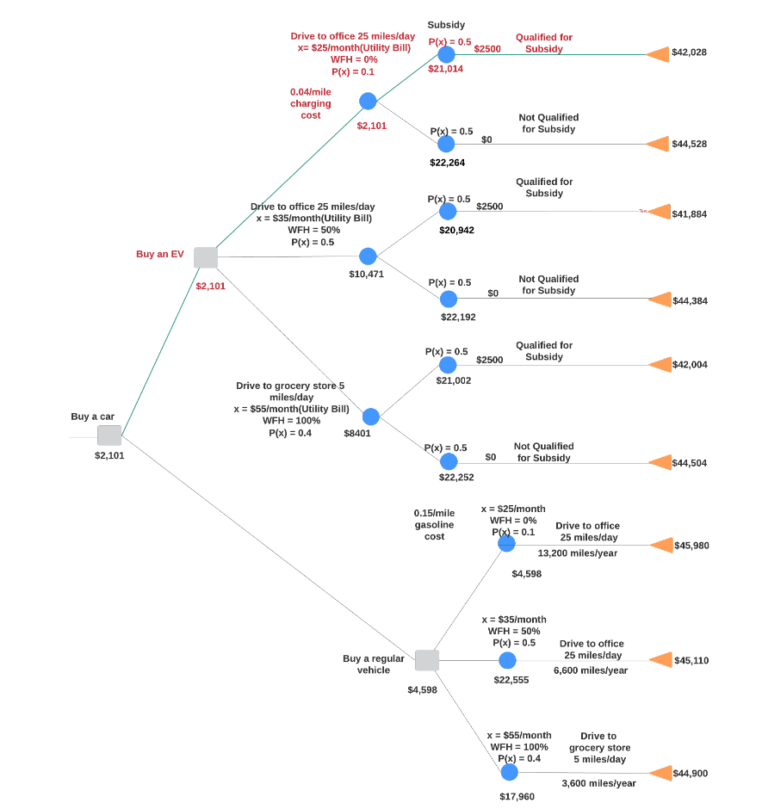

Figure7: Optimal Strategy for Electric Vehicle vs. Regular Vehicle

**Interpretation of Analysis Results** The data collected for analysis is from the ledger managed by the government which has real-time statistical data of gasoline and electricity for period 2001 to 2021. Out of the huge dataset, we have narrowed down on the average price of gasoline and electricity to analyze the problem statement.

What can be learnt from the analysis? Results from descriptive analysis shows the gasoline prices to be rapidly increasing at an average rate of 6% every year, whereas electricity prices grew only 1.2% every year. This presents a view to compare and estimate expenses for the vehicle’s fuel cost in which electricity seems to be a decisive choice. Also factors like gradual depletion of crude oil to produce gasoline and increasing sales of regular fuel vehicles contribute rationally. This has been analytically proved during prediction analysis for the next 10 years, done on both entities.

What do we infer from critical thinking? Upon critically analyzing the decision by supplying the decision tree with few uncertainties like WFH policies, green energy subsidies etc., we arrive at the most cost-efficient decision – to buy an Electric vehicle.

Other supporting articles and references:

[Alternative Fuels Data Center - EV Benefits and Considerations](https://afdc.energy.gov/fuels/electricity_benefits.html)

[Forbes - Electric cars are coming and if you don't like it, Tough!](https://www.forbes.com/sites/neilwinton/2021/03/09/electric-cars-are-coming-and-if-you-dont-like-it-tough/?sh=26d92aa3698f%20)

# **Conclusion**

**Recommendation:** As a result of decision analysis, buying an electric vehicle is a worthwhile decision.

**Why?**

* State and federal government bodies have planned to provide increased green energy subsidies to 30% of customers in next few years.
* Tesla has planned to build more charging stations in Texas following their plan to move the company’s headquarters to Austin, TX.
* 50% fall in battery prices as more powerful new solid-state technologies will be adopted by most EV manufactures by 2025.
* As COVID situation is getting under control with about 2000 cases/day in Texas today, industries are willing to lift WFH policies at end of 2021.

# **Shortcomings and/or Suggestions**

* Work from home policies depend on the gravity of COVID spread in the US. Due to thorough vaccination and sanitary protocols, the number of daily cases has been drastically reduced. However, with the evolution of the virus into new variants and other uncertainties, corporate companies are keen on opening workspaces in an incremental capacity approach.
* Analysis on Selective Data: The analysis was based on data of average prices only as the decision problem is based on cost-efficiency. A holistic approach would be on analyzing data based on factors like retail sales, net production and/or availability of resources for both electricity and gasoline.
* Analysis on Sample Population: In decision analysis, the decision maker is assumed to be a corporate employee whose employer has work from policies. This is a sample out of a large working population. Probabilities would differ if a large population and working sector was considered.